How to accept insecure certificates in chrome:

Sometimes you will see insecure certificate error message when you run your automation scripts. You need to handle them for your automation scripts to proceed.

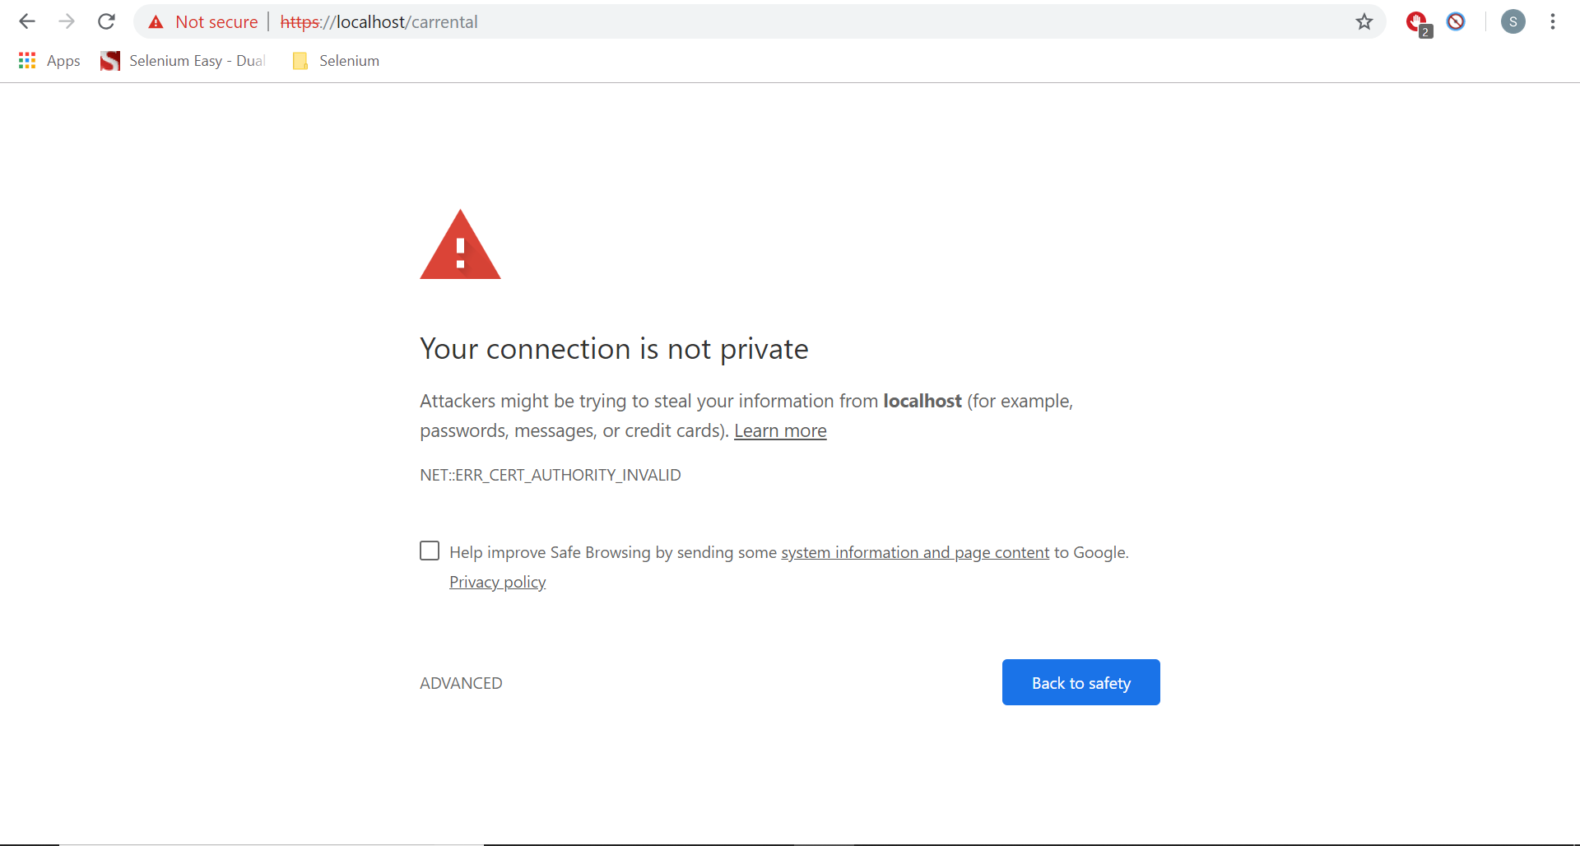

We will use chrome options to accept the insecure certificates.

**package** Selenium;

**import** org.openqa.selenium.WebDriver;

**import** org.openqa.selenium.chrome.ChromeDriver;

**import** org.openqa.selenium.chrome.ChromeOptions;

**public** **class** AutomationBar {

**public** **static** **void** main(String[] args) {

//Disabling Chrome push notifications

ChromeOptions ops = **new** ChromeOptions();

//ops.addArguments("disable-infobars");

ops.setAcceptInsecureCerts(**true**);

System.*setProperty*("webdriver.chrome.driver", "C:\\BrowserDrivers\\chromedriver.exe");

WebDriver driver = **new** ChromeDriver(ops);

driver.manage().window().maximize();

driver.get("https://localhost/carrental");

}

}